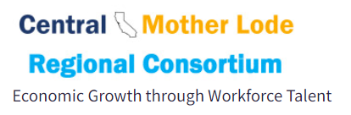

Steering Committee Meeting Minutes
Porterville College/ Cafeteria - Date/Time: February 11, 2022 9:30-2:30 pm
SC Voting Members: Tony Cordova, Becky Barabe, Ganesan Srinivasen, Bryan Tassey, Osvaldo Del Valle, David Clark, Danell Hepworth, Armin Rashvand, Justin Garcia, Kris Costa, Nicole Griffin
SC Key Talent and Guests: Thad Russell, Gary Potter, Nora Seronello, Beatrice Licon, Loren Kelly, Autumn Garcia, Stephanie Baltazar, Krista Vannest, Rozanne Hernandez, Jessica Grimes
Time | Agenda Item | Minutes
9:30-9:45 am | Welcome and Introduction | Jessica Grimes opened up the meeting and asked attendees to introduce themselves. She thanked Porterville College for hosting the meeting. After some discussion about the format and length, it was recommended to do a 5, half-day sessions during the third week of September (9/19/2022-9/23/2022).
9:45 to 11:45  am | CTE New Instructor Training | Loren Kelly presented on offering three professional development sessions (Academic Career Coaching and CTE Instructor Training) as has been offered in the past with many participating colleges commenting on this success.  Item Price  CTE Instructor Training Level 1 - three cohorts $60,000  CTE Instructor Training Level 2 - one cohort $10,000  Academic and Career Coaching Training - one cohort $20,000  TOTAL $90,000  VOTE: Kris Costa motioned to approve Loren Kelly’s sessions as designated for 2022 and 2023 with dates to be mimicked for 2023 with SWP 6 funds. Becky Barabe seconded the motion. The motion was approved unanimously.
 | ZTC CTE Course Updates | Kelsey Smith provided a virtual update on the CTE Open Education Resources (OER) Zero Textbook Cost (ZTC) project that was approved from the SWP 4 CRC Region-Wide Open Educational Resources for CTE Courses (2019-2020 to 4/1/2022). Faculty from Madera Community College, Merced College, Modesto Junior College, Taft College, and West Hills College Lemoore participated in the project.  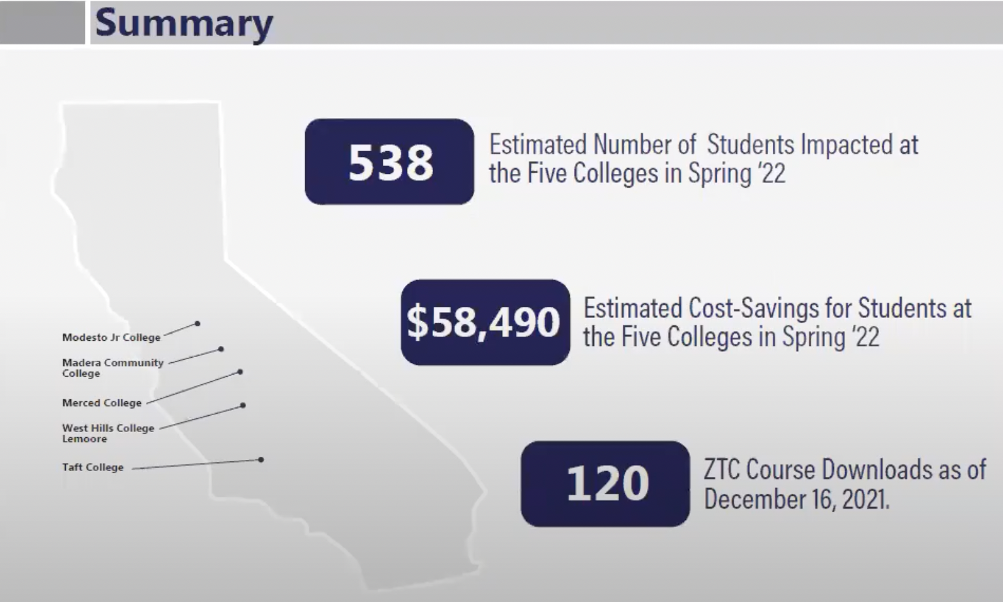
 | LinkedIn Learning | Ryan Zervakos, from LinkedIn, provided updates on the following:  LinkedinLearning (LiL) was a project approved in 2019-2020 with the CRC Region-Wide LinkedIn Learning Project. Faculty can now access LiL content in Canvas and migrate the content into their shells where students can access it without having to log into LiL, first, because it automatically provisions licenses. LiL is adding 50,000 videos/week. If, however, students do not create a Linked In profile, the learning history does have to be purged because of privacy, so Ryan stressed the importance of promoting and/or marketing LinkedIn to retain the data.  Talent Insights, a new platform, provides alumni data, provided the user has identified the community college s/he has attended, so the push to market LinkedIn has a direct correlation to how much data is available, hence the Single Sign On push at the beginning of the pilot. He also mentioned that 4-year colleges tend to do marketing campaigns and provide free material to incentivize signing up.  Among the TI features is the ability to create several reports, such as a talent pool and company profile report because of privacy. While the data can be exported, it does not allow personal information. The job postings that TI accesses is from CalJobs, Indeed, as well as LinkedIn that it scrapes every day. This platform has 4,500 users and over 145,000 videos focused on a variety of topics related to jobs, including DEI. College of the Sequoias and Inland/Empire Consortium is using it. The skills identified for occupations are a combination of LinkedIn categories and from users.  Becky mentioned she would be interested in doing a regional project around LinkedIn and hiring qualified, diverse candidates.  Ryan plans to return to provide more updates and mentioned he’s available to help market these platforms.
 | Needs Assessment for Employers - CLNA for students?  Incumbent Worker Study  Verify Viper Tool Upgrades  CVML LMI Updated Report is available  EMSI proposals | Jessica stated that the CLNA report has been changed and is now due at the same time as the Perkins IC report on May 15th. College deans do not have to receive approval from the regional chair. Also, the CLNA is supposed to be an update of the previous one from 2022.  Nora Seronello updated the SC on the following projects:  Surveys in support of CLNA: Nora is working on an Employer Engagement Survey and then a second survey for associations and businesses by partnering with Chico State to help administer the survey via local business contacts David Teasdale purchased. Tony mentioned that the former Comprehensive Learning Needs Assessment (CLNA) was difficult to administer and made a recommendation to streamline the process, ie create a survey that can do double duty for the region and for local colleges by disaggregating the results by county and/or subregions and develop a student need assessment. Kris mentioned it might be helpful if deans prepared advisory members of the survey. Nora requested feedback from local colleges within two weeks. Dave mentioned that Reedley College is working on an incumbent worker survey to help with the needs assessment for the CLNA.  Verify Viper: Nora mentioned that VV has a few upgrades, including the certification of certain positions based on the SOC codes as well as the value of the certification in terms of the salary increase. In addition to information on certifications, it also links licenses to SOC codes as well as the positive salary increase as a result of having the license.  EMSI: Nora mentioned that Craig Hayward from BC asked her about getting access to alumni outcomes data for the last two years from EMSI. EMSI stated that it could provide the report if the CCs gave them student data for as little as $30k or as much as $70k. After some discussion, it was decided that the SC was not interested in pursuing this option any further.
STEERING COMMITTEE VOTES (CTE DEANS)

12:45-1:45 PM | December 7, 2021 SC Minutes | Kris made a motion to approve the December 7, 2021 minutes with the amendment of Jonna Schengel’s name spelled correctly. Becky seconded this motion, and the minutes were passed unanimously.
 | Program Endorsement Approvals | Five programs were submitted for approval in the Regional CTE platform: Personal Training Certificate COA (PC), Food Service Management AS (CC), Industrial Electronic AS (TC), Social Work and Human Services COA (CC), and Electrical Technology (AS). Kris made a motion to approve the submitted programs. Becky seconded the motion, which was unanimously approved.  A few recommendations were made to streamline the program approval process, including providing a list to the SC regarding new programs being submitted to the COE for LMI reports to encourage discussion and to mitigate the potential for competition and ensuring that the notifications for voting on the programs are not overwhelming, ie a barrage of many emails.  Nora mentioned that when she conducts LMI research, she does take into account the proximity of neighboring colleges and their programs, and she mentioned that she could provide a list of programs.
 | SWP 6 Increased Allocation | Jessica stated that on January 13, 2022, the Chancellor’s Office sent a memo regarding an augmentation of the SWP 6, which amounted to $2,035,453. This amount stemmed from the remainder of the FY 2021-22 Strong Workforce Program (SWP) allocation, which was increased to $290.4 million, from $248 million in the previous year. The October 11, 2021 guidance memo provided the SWP allocations for $248 million of the $290.4 million.  Kris motioned to approve the distribution allocation. Becky seconded the motion, which was unanimously approved.  Jessica said that she would request a vote from the CEOs to approve the distribution that the SC recommended. She also stated that the Chancellor’s Office has communicated the need to expend funds within the timeline and that other regions are planning to advocate for an extended timeline for SWP 5. Jessica said she would join her voice in advocating for an extended timeline to expend funds.
BREAK (1:45-2:00 PM)
DISCUSSION ITEMS
2:00-3:30 PM | Current status of Regional and/or Region-Wide Updates/Revisions (SWP 6 Increased Allocation) | Jessica stated that since SWP 6 had been augmented, the Chancellor’s Office has asked that all projects be updated to reflect the increase of funding by March 1st in NOVA. She further mentioned that the total allocation in NOVA is under budget by ~$3m and encouraged deans to review their budgets. Additionally, she stated that she and Beatrice Licon, Budget Analyst for the CRC, are planning to conduct webinars
 | Non-SWP Grants | Jessica mentioned that since there have been many grants, there was mention of potentially developing an ad hoc committee on grants to do research on which grants might be suitable for the region. Another idea that was mentioned was to convene a group to develop a plan on what types of grants would be most suitable for the CRC to pursue. This topic was a discussion item that may continue, depending on interest.
 | Regional Plan, Ad Hoc Committees (Marketing, Data, and Grants) | Jessica stated that she is working on the regional plan and would like to have it completed soon, as early as 2/18/2022, but that there are many items to update. She mentioned that she will be seeking feedback and will provide a list on specific items. In that list, she indicated that the governance document includes defunct positions and that there is a need to revisit this document.  Jessica stated that the Marketing Ad Hoc Committee is continuing to meet. Also, she mentioned that both she and Nora discussed starting an Ad Hoc Data Committee to meet quarterly and provide recommendations and/or a review of COE reports/surveys to ensure they are reflective of what the CRC needs. Another reason for the committee was to consider forecasting what the CRC needs given the shifts in the economy and unpredictable events, such as the pandemic that has caused the Great Resignation/Reshuffle. Jessica mentioned that women have left the workforce but it wasn’t clear what has happened in the CVML. It was suggested that perhaps the Dean’s Brown Bag might be the best platform to start these conversations. Jessica also stated that she is chairing a Data and Equity subcommittee with other regional chairs and that there might be some alignment with the work she’s doing and the CRC.
 | Dean Updates: Round Robbin | Kris mentioned that WHCL, COS, RC, and PC are partnering to do a summer program called the Industrial Careers Jumptsart Academy as a pilot program. She stated that the preliminary budget is $190k and that the project would benefit from sub-regional directors (to be hired), and K12 PCs. After the planning has finished, there will be a request to the SC to use SWP 6 funds. Others, 11 deans to be exact, expressed an interest in joining this project after the pilot has occurred and made the recommendation that it could be a region-wide project in its next iteration.  Another project that Kris mentioned is doing a data mine for paramedics.  Jessica stated that Pedro had the following updates from the CCCAOE:  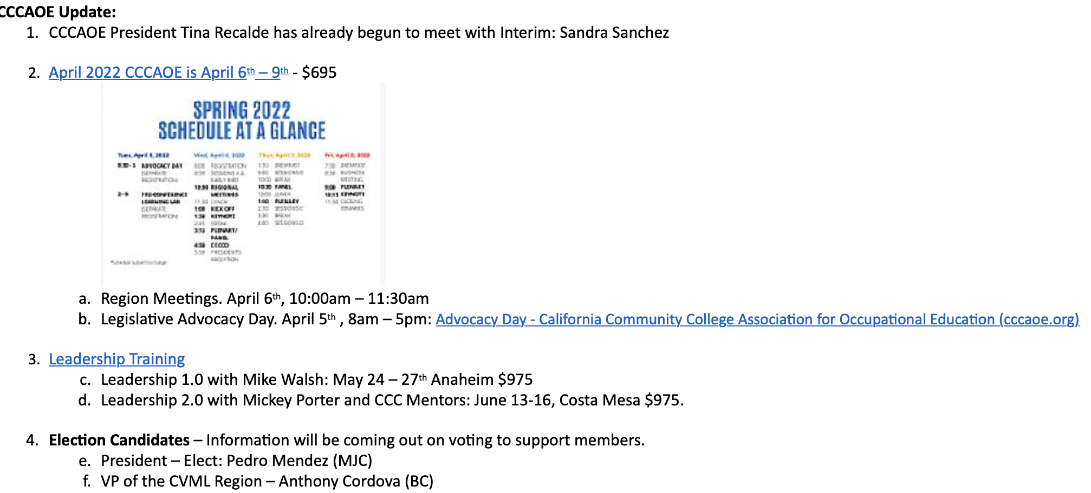  The last item discussed was the Monterey Retreat. It was decided that a more paired down retreat was needed and that the focus would be on pivoting and resetting priorities. The following individuals signed up to be part of the Planning Committee: Kris Costa, Stephanie Baltazar, Jessica Grimes, and ___________.
 | UPCOMING MEETINGS: | Jessica announced that the next meeting will be at CCCAOE on April 5th (4:30-8:30 pm). The region meeting will be on April 6th (10:00-11:30 pm).  Becky stated that Fresno City College will host the next meeting on April 26th (8:30 to 2:30 pm).  For more information, please use the following link to find out about future meeting dates.

CRC AD HOC COMMITTEE Updates can be found here:
- Marketing Ad Hoc

M/S/A Item: Program Status http://crconsortium.com/program-recommendations-processes/

Program Names | College | Submitted By | Submission Date | Status | Vote Counts
Personal Training Certificate COA | Porterville College | Joseph Cascio | 12/14/2021 |  | 10
Foodservice Management AS and Foodservice Management COA | Columbia College | Elissa Creighton | 12/10/2021 |  | 10
Industrial Electronics AS | Taft College | Norberto Lopez | 01/08/2022 |  | 9
Social Work and Human Services COA | Columbia College | Elissa Creighton | 01/14/2022 |  | 10
Electrical Technology AS | College of the Sequoias | Daniel Alvarado | 01/28/2022 |  | 9

